Power Law Distribution:

Definition: In statistics, the power law is a functional relationship between two quantities, where a relative change in one quantity results in a proportional relative change in the other quantity, independent of the initial size of those quantities: one quantity varies as power of another.

Follows the 80-20 principle.

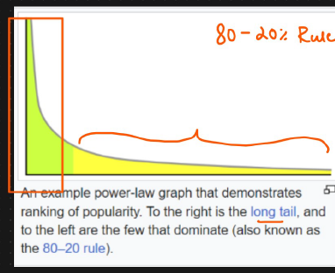



Example: IPL

20% of the teams is responsible for winning 80% of the matches.

80% of the wealth is distributed with 80% of total population.

80% of the total crude oil is with 20% of the nation.

Frequencies of words in most languages.

20% of the major defects fixes 80% of upcoming defects in a product.

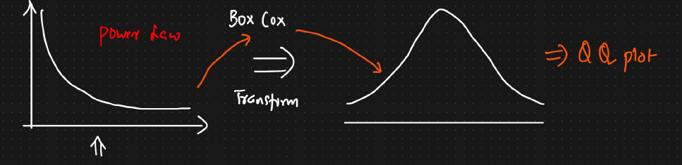

Pereto distribution [80-20%]